**AIR QUALITY MONITORING**

Developing a Python script for air quality monitoring involves several steps. Here's a high-level overview of the process:

**Python program for developing Iot devices:**

**import time**

**# Function to read air quality data from the sensor (replace with your actual sensor code)**

**def read_air_quality():**

**# Replace this with your sensor reading logic**

**air_quality_data = {**

**"pm2.5": 10.0, # Replace with actual PM2.5 reading**

**"pm10": 15.0, # Replace with actual PM10 reading**

**"co2": 400, # Replace with actual CO2 reading**

**}**

**return air_quality_data**

**# Main monitoring loop**

**while True:**

**try:**

**air_quality = read_air_quality()**

**print("Air Quality Data:")**

**print(f"PM2.5: {air_quality['pm2.5']} µg/m³")**

**print(f"PM10: {air_quality['pm10']} µg/m³")**

**print(f"CO2: {air_quality['co2']} ppm")**

**# Add data storage and analysis logic here**

**time.sleep(300) # Sleep for 5 minutes (adjust as needed)**

**except KeyboardInterrupt:**

**break**

**# Close any resources or connections when exiting the script**

**# Add your data storage and analysis logic here**

**print("Monitoring stopped.")**

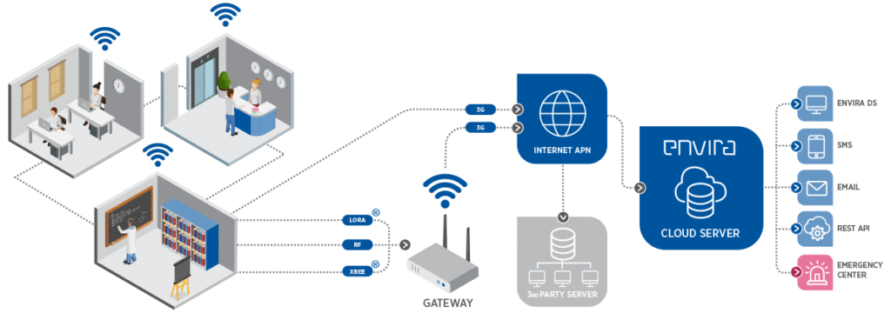

Developing a Python script for air quality monitoring involves several steps. Here's a high-level overview of the process:

1. **Set Up Your Environment**:
   * Ensure you have Python installed on your system.
   * Use virtual environments to manage dependencies.
2. **Choose an Air Quality Sensor**:
   * Select an appropriate air quality sensor (e.g., particulate matter, gas sensors) based on your requirements.
3. **Wiring and Hardware Setup**:
   * Connect the sensor to your Raspberry Pi, Arduino, or microcontroller, depending on your hardware.
4. **Install Required Libraries**:
   * Install libraries for sensor communication, such as **Adafruit CircuitPython** or **smbus2** for I2C communication.
   * 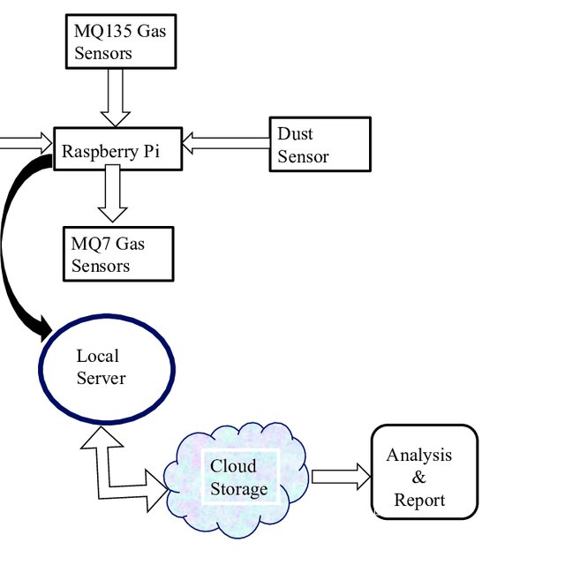
5. **Read Sensor Data**:
   * Write code to read data from the air quality sensor. This may involve reading analog or digital data and calibrating it.
6. **Data Processing**:
   * Process the sensor data if necessary (e.g., converting raw data into meaningful air quality metrics like PM2.5 or AQI).
7. **Data Storage**:
   * Choose a storage solution (e.g., SQLite, MySQL, or cloud-based databases) to save the air quality data.
8. **Data Visualization**:
   * Use libraries like Matplotlib, Plotly, or web frameworks like Flask or Django to create real-time or historical data visualizations.
9. **Data Analysis and Alerts**:
   * Implement logic to analyze air quality data and trigger alerts or notifications if air quality falls below a certain threshold.
10. **Logging and Reporting**:
    * Create a system for logging and reporting the air quality data over time.
11. **User Interface** (Optional):
    * Develop a user-friendly interface using tools like PyQt, Tkinter, or web technologies.
12. **Testing and Calibration**:
    * Test your setup extensively and calibrate the sensor for accuracy.
13. **Deployment**:
    * Deploy your script on your desired hardware platform and ensure it runs continuously.
14. **Data Sharing** (Optional):
    * If needed, implement APIs or protocols to share air quality data with other devices or services.
15. **Maintenance**:
    * Regularly monitor and maintain your air quality monitoring system to ensure it continues to function correctly.

**Project Submitted By**

**Name:V.Kavipriya**

**Email id:kavipriyavenkateswaran10@gmail.com**

**NMReg.no :au713921106021**

**Topic : AIR QUALITY MONITORING**

**College code : 7139**